ECEN4243

LAB 0

Jordan Paul, Ben Sailor

https://github.com/jordanpaul98/ECEN4243_CompARC/tree/main/LAB_0

files:

* FSM.do, FSM.sv, FSM_tb.sv
* regfile.sv
* regfile.do, regfile_tb.sv
* regfile_testbench.do, regfile_testbench.sv, regfile.tv
* regfile_gen.py

**Run: vsim -do regfile.do**

* test bench uses Case with pre enter cases to test the regfile.sv
  + outputs test to reg_test.out
* general test cases, exploring the functionality of the registers and operations

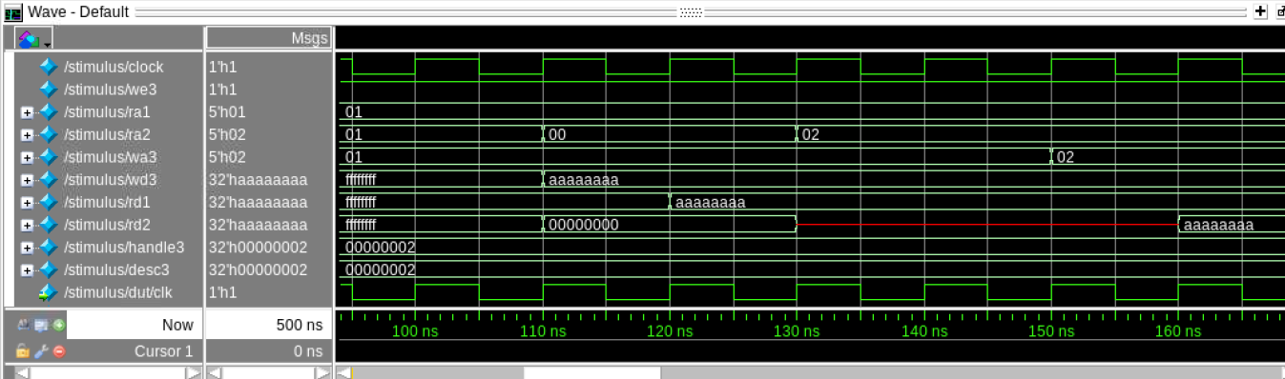

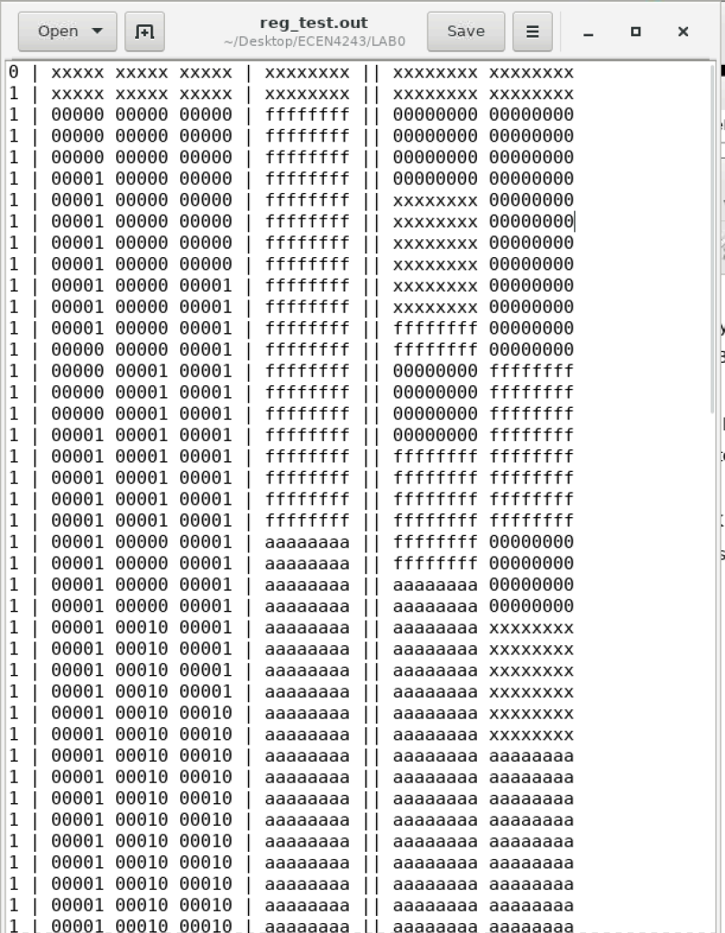

**Run: vsim -do regfile_testbench.do**

* test bench using test vectors loaded in from regfile.tv generated from regfile_gen.py
* testes every register state (126) testes (minus 2 duplicated test cases)
  + testes = (2 ^ num_registers) * (2 ^ register_bits)
* will print error message if a test failed on which line number test it failed on.

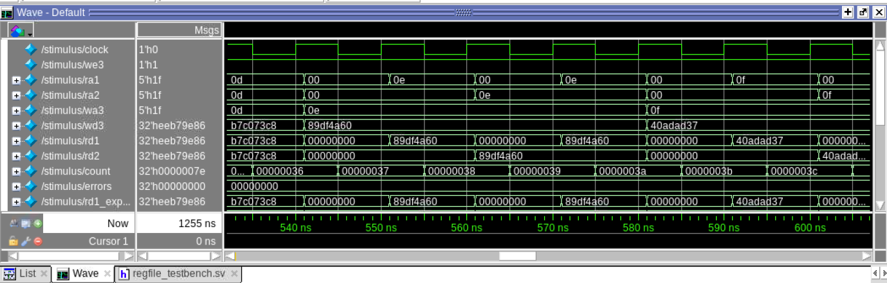

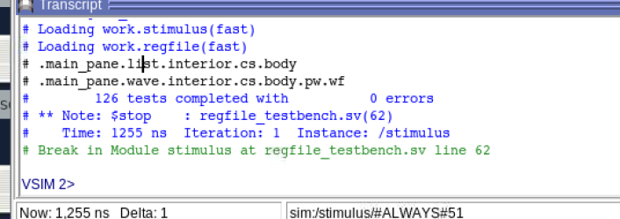

Test vectors input (112 bits)

